The nature of Allah

- Muslims believe in one God, Allah, whose word was received by the Prophet Muhammad on behalf of humankind.

- The Qur'an contains guidance for Muslims on the nature of Allah, and how to live a good life that pleases Him.

- Tawhid (Monotheism) : the belief in the oneness and unity of Allah as expressed in the first of the Five Pillars of Islam, the Shahadah. Belief in this oneness or unity of Allah is an essential aspect of Islam.

- Islam is a monotheistic religion. A Muslim should live a life in submission to the will of Allah in all things.

Shirk (polytheism): is the sin of worshipping someone or something other than Allah . This is directly opposed to Tawhid, the belief in the oneness of Allah and that Allah alone is worthy of worship.

Muslims say there are some things that are so bad that they may never be forgiven. These things include shirk.

Q- What do Muslims believe about Tawhid?

Q- What is meant by shirk?

سورة الإخلاص
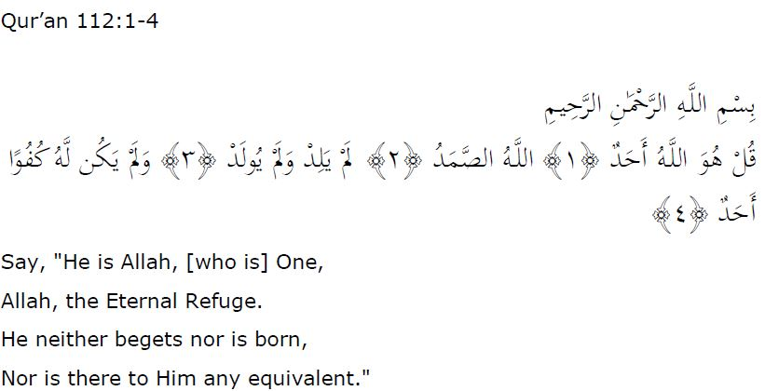
Ikhlas (الإخلاص):
- Sincerity or purity…Islamically ,Ikhlas denotes purifying our motives and intenions to seek the pleasure of Allah.
- This surah was revealed to the prophet during the early days of Islam when the polytheists and pagans of Ma'kah challenged the prophet saying " Give us the genealogy of you Lord".
- This surah directly supports the first pillar of Islam shahadah (witness).
- The first Ayah proclaims the oneness of Allah.
- The second Ayah declares that Allah is As Sammed (one of Allah is names) which means the one who every one depends on but the one who doesn't depend on anyone. It also indicates that Allah is unlike His creation.
- The third Ayah describes that He was not born nor did He give birth.
- The last Ayah declares that Allah is beyond comparison.

Q- Explain how this surah may help a Muslim to understand the nature of
Allah.
Q- What is the mining of monotheism ?
Q – What is the opposite of the word ( polytheism)?

