Maths Homework :02
Year: 8
Student Name: ________________ Date: 08/10/2020

Q1. Put these cards in order from the smallest to the biggest : ( 1 mark )
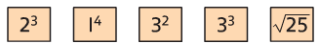

_________________________________________________________
_________________________________________________________
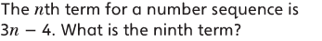
Q2. ( 1 mark )

_________________________________________________________
_________________________________________________________
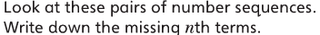
Q3. ( 1 mark )
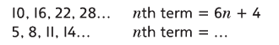

Q4. Simplify as fully as possible : ( 1 mark )
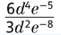
= ____________________________________

Q5. What is the value of x ? ( 1 mark )



