المستثنى: اسم يأتي بعد أداة استثناء ليخالف ما قبله في المعنى.
أدوات الاستثناء:
)إلا (– )غير – سوى( – )خلا – عدا – حاشا(
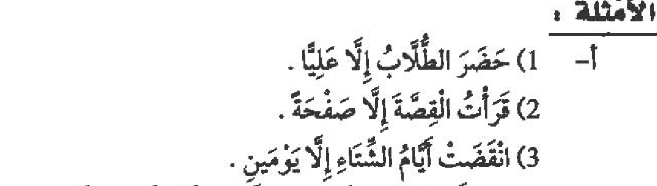
الكلام مثبت والمستثنى منه موجود.
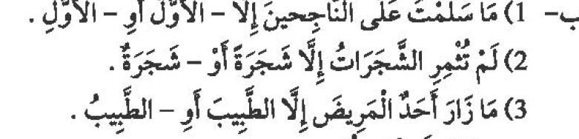
الكلام منفي والمستثنى منه موجود.

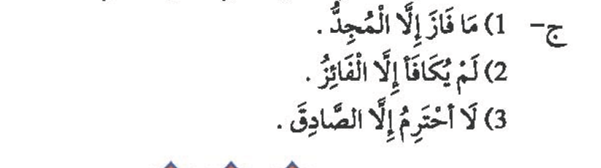
الكلام منف والمستثنى منه غيرموجود.
Book pg.149

القاعدة: 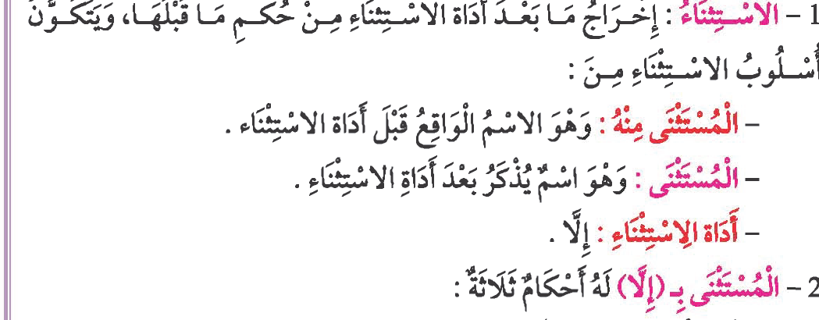
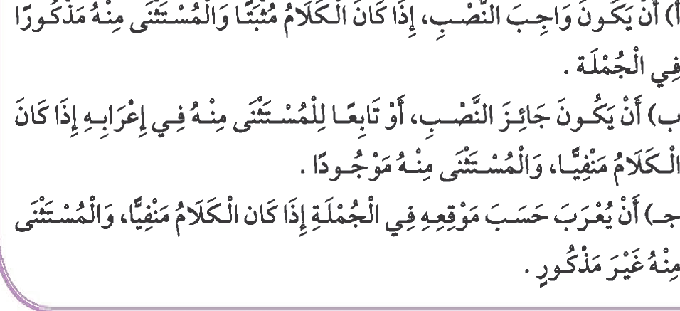

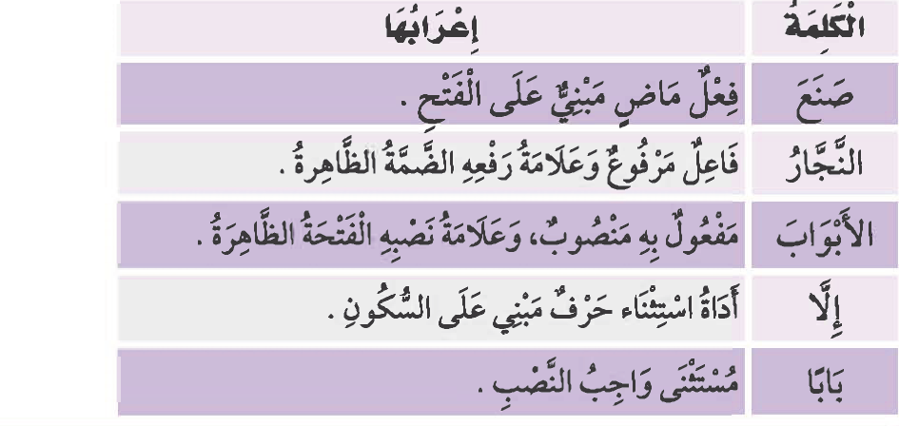

الاستثناء ب ( عدا – خلا )

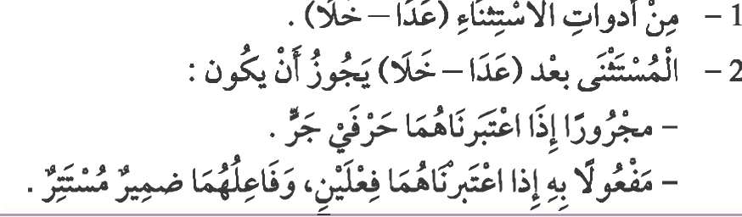
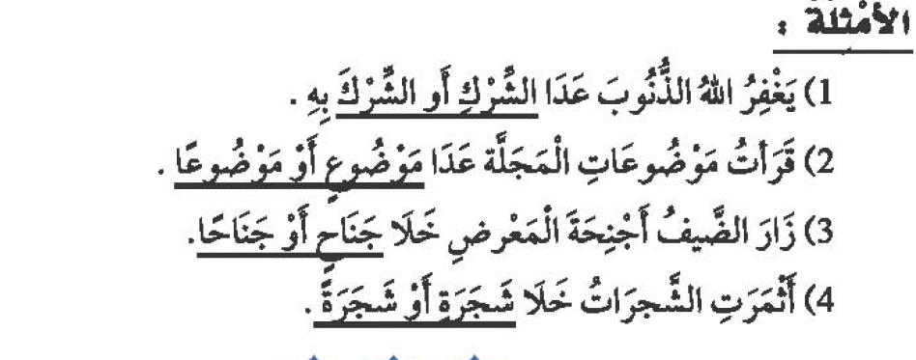

الاستثناء ب ( غير – سوى )

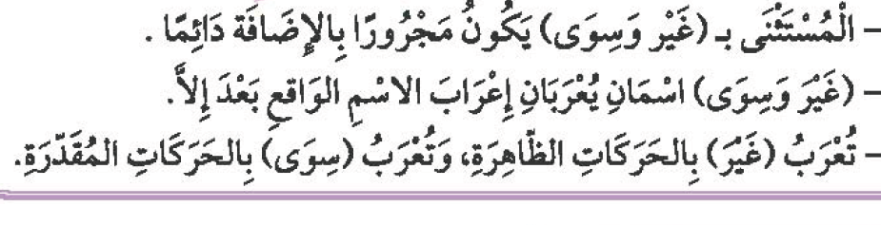
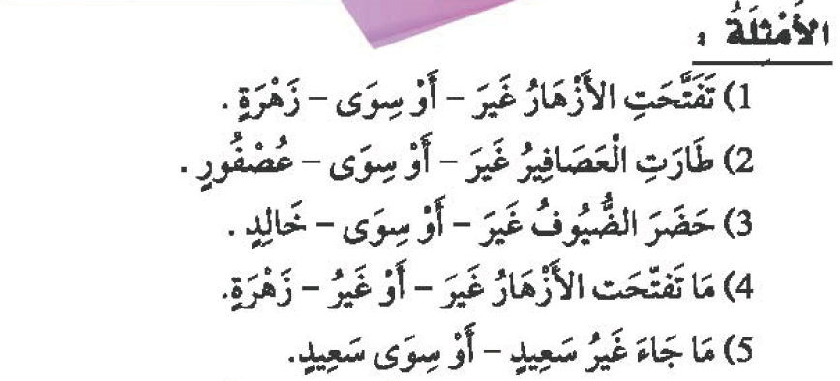
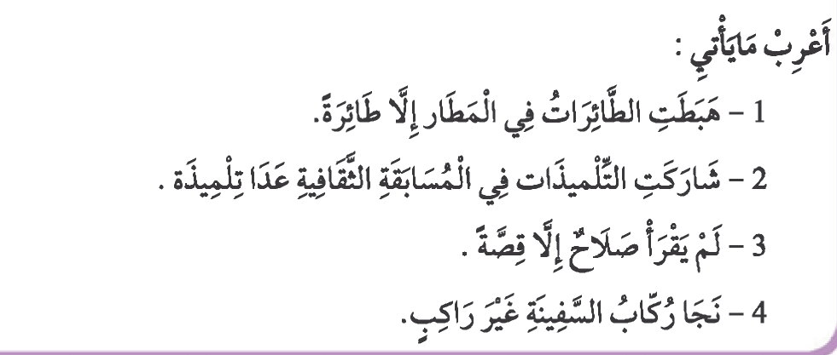

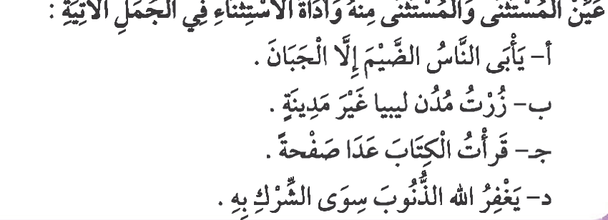

Islamic Studies
The Delegation
In the eleventh year of Prophet hood, while the prophet (blessings and peace be upon him) was at Aqabah, he met a group of men from Madinah (at that time known as Yathrib) and invited them to Islam. They were neighbors of the Jews and had heard mention of a Prophet, who was about to come. After some deliberation they accepted his teachings and became Muslims.
The following year, twelve people from Madinah met the prophet and gave him their pledge that they would believe in one God and worship Him alone. They also pledged that they would not steal or kill their children. This undertaking is known as the First Pledge of Aqabah. The prophet (blessings and peace be upon him) sent Mus’āb bin Umayr with them. Mus’āb was a handsome young man who was a proficient reciter of the Qur’ān. He accompanied them to Madinah, preached Islam to the people, and led them in prayer.
The next year, Mus’āb bin Umayr (may Allah be pleased with him) returned to Makkah with seventy-three men and two women from Madinah. They all met with the Prophet, pledged their allegiance to him and promised to protect him and the other Muslims. This is known as the Second Pledge of Aqabah.

The Prophet's Migration
After the second pledge of Aqabah, the prophet (blessings and peace be upon him) ordered the Muslims who were with him in Makkah to leave for Madinah. He could no longer tolerate their suffering at the hands of the Quraysh. The emigration from Makkah to Madinah was not easy. The Quraysh put many obstacles to prevent the Muslims from leaving Makkah. Some were forced to leave their wives and children behind, and to travel alone. Others had to leave all of their wealth and belongings and travel empty handed.
On the 27th of Safar in the 14th year of Prophet hood (622 C.E.), Allah granted permission to the Prophet to travel to Madinah. Abu Bakr, the Prophet’s close friend, accompanied him on this blessed and historical journey. On the eve of that day, the Quraysh had gathered to make one final attempt to assassinate the Prophet. They agreed that each tribe would provide a young man and together they would attack the Prophet, each man striking a blow. Allah informed His Messenger of this plot, and so he (blessings and peace be upon him) secretly left the house without the men of Quraysh noticing him. Over the years, the prophet acquired such a reputation for honesty that the disbelieving Quraysh would leave their valuables with him to look after. Before leaving, the Prophet (blessings and peace be upon him) charged Ali with the responsibility of returning all the properties to their rightful owners.

Quraishi's plot to kill the Prophet in 13 BH
The call started to be dangerous for Quraysh, even its masters and nobles, as it threatened their interests, their prestige and their social position among the Arabs.
They saw that all the Companions had left for Medinah, and understood that this city would be a fort and protection for the Prophet (peace be upon him) and his Companions. They also realized that if the Prophet reached there, the city would become a centre for the call from where Islam would spread throughout the Arabian Peninsula. If this happened, the situation would no longer be under their hands and control.
The Muslims faced many different types of difficulties, each according to their different circumstances and conditions. They faced all of this with patience. They left the trials of harm and persecution they used to experience to face the difficulties of leaving their homeland and money. But this immigration had to be in order for the Islamic call to rid itself of being harmed and mocked, and to help establish a new community in a safe place from where they could spread the call throughout the world. For these reasons, immigration from the land which fought Islam to the land where Islam could flourish became obligatory.
In this way, they would leave their condition in which they suffered psychological and physical harm, with the disbelievers even planning to kill the leader of the call, the Prophet (peace be upon him) himself, to the extent that the Prophet (peace be upon him) was scared to leave to Medina; the Prophet remained in Mecca, waiting for Allah’s permission to immigrate.
The disbelievers gathered in Dar An-Nadwa to discuss what to do with the Prophet. Iblis was present with them in the form of an old sheikh from the tribe of Najd. Everyone gave their views, but every time Iblis rejected the views and was not happy with their ideas. This continued until Abu Jahl said, “I think we should choose one strong youth from every tribe of Quraysh, and give each one of them a strong sword for them all to hit him (the Prophet) at one time, all together, as one man. In such a way, all the tribes will participate in the murder.”
To this, the sheikh from An-Najd said, “This, and only this, is the correct view; all the other ideas are not suitable.” So they parted after all of them agreed on this plan.

The Prophet Enters Madina
The camel has, since olden times, proved to be a very useful animal for desert journeys. It has shown to be dependable and sturdy animal for desert transport. The reason is that it has been created with certain special features which are not to be found in any other animal. It can walk in the hot desert under scorching sun for days and days without feeling tired or thirsty and arrive at the intended destination with his rider - the traveller. Hence the Arabs have named this animal as the 'Ship of the Desert'.
It was this same animal which had fulfilled in excellent manner the task of conveying the Prophet of Islam from Mecca to Madina. It had also served well in the cause of Islam.
The Prophet, tired of the tortures by the disbelieving Quraish, decided to migrate from Mecca to Madina. He had hidden himself in the cave of Thaur to protect himself against the enemies who wanted to kill him.
Imam Ali (a) sent three camels with a guide to the cave. The Prophet, mounting one of the camels, left the cave in the dark of the night, destined for Madina. On the way, several miracles took place which showed that God's help was always there to protect the Prophet against the attacks of his enemies.
The distance between Mecca and Madina is about three hundred fifty kilometres. In those days, it used to take eleven days to travel between the two places. But in this instance, the camel carrying the Prophet took only eight days to reach Madina. The Prophet (S) travelled at night, resting during the day-time. He was doing so to protect himself against the desert heat as well as to keep from being seen by the enemies.
On the eighth day, the Prophet along with his companions reached a place known as Quba, just two kilometres outside Madina. There he rested for several days, awaiting Imam Ali (a) and family members. After their arrival they proceeded to enter the city. On seeing the date trees on the outskirts of the holy city, they felt happy and relieved to have finally come out safe from the tortures of their enemies.
The people of Madina keenly awaited his arrival. Suddenly someone from the top of a hill announced that the Prophet had arrived. On hearing this, the people became wild with extreme joy and recited “Allahu Akbar!”, “Allahu Akbar!” - “Allah is Great!”, “Allah is Great!”
The Prophet dismounted the camel just outside Madina and sat down under a date tree. People rushed forward to greet and welcome him to their city. He was loved by all and everyone was keen to salute him. After the traditional welcome ceremony, the Prophet mounted his came to enter the holy city. All around, there were expressions of great joy. The children got together and in loud voices chanted the following welcoming poem:
“Tala-Al Badru Alaina
Min Thanayatil Wadai
Wajaba-Shukru Alaina
Ma Da'allaha Da'i”
“The full moon is shining on us from the area of gardens. We must offer thanks (to Allah) so long as anyone prays before Allah.”
“Ayuhal Mab-Uthu Fiina
Je'ta Bil Amril Mutai
Je'ta Shar-Raftal Madina
Marhaban Ya Khaira Dai”
“O' the one sent to us, you have come with commands which we shall obey. You came and graced Madina, we salute and welcome you, 'O' the best caller (towards Allah). “
It was hardly three years since the people of Madina had embraced Islam and had started to worship Allah. The young boys in the city were given a job to eradicate the worship of idols. Wherever they saw an idol, they destroyed it and set fire to it.
One day, the youths came to know that Omar bin Janah, the chief of Bani Salma tribe, had still preserved his idol and worshipped it. In order to impress upon him the uselessness of worshipping idols made of wood, they removed it from his place and threw it down a pit. The chief, on tracing the idol to where it was lying, brought it back, washed it and kept it in its original place. But the next day again it was removed and thrown into the pit.
The chief was very much disturbed at this. For the last time he brought home this idol and cleaned it. He then put his sword around its neck and said to the idol: “If henceforth anybody comes to you, promptly take action and kill him with the sword.”
On the next day, the idol was again missing. This time he found it tied to a dead body of a dog. There was no effect at all of the sword which he had tied around the neck of the idol. This incident made him lose faith in his man-made wooden idol. He abandoned the idol-worship altogether. On becoming a Muslim, he uttered a poem as under:
“Alas! O' my idol! If you were my god, you would not have reached this stage and I would not have seen you in the pit along with a dead dog. I have now put my faith in the Almighty Allah, from Whom come all blessings. It is He Who has freed me from darkness of ignorance.”
This is one of the examples of how the young Muslim volunteers of Madina helped the Prophet in putting an end to idol worship and spread the true message of Islam.
When the Prophet entered the city amid great rejoicing, everyone wanted him to stay at his house. Particularly, the chiefs of all the tribes were keen to have the Prophet as their guest. Everyone insisted but the Prophet ordered: “Let the reins of the camel loose and I shall get down and stay where it stops by itself.”
The camel went ahead further and further till it stopped at a big open land. It was a place where people used to dry their dates and other farm produce. It knelt there and sat The Prophet dismounted and asked the people, whose land it was. They replied that it belonged to two small children by the name of SAHL and SUHAIL.
Nearby was the house of ABU AYYUB. ABU AYYUB'S mother came forward and took away the luggage of the Prophet to her house. People again persuaded him to put up in their house but the Prophet asked: “Where is my luggage?” The reply was that the mother of ABU AYYUB had taken them to her house. And the Prophet said: “One has to go to stay at a place where one's luggage and belonging go to.”
Sometime later, the name of Yathrib was changed to 'Madina-tun-Nabi' i.e. 'the City of the Prophet.' He named the people of that city as ANSAR (helpers) and those who had migrated from Mecca as MUHAJIREEN (immigrants). All these people, i.e. the Ansar and the muhajireen got together and united in the common bond of brotherhood of Islam.

The Significance of the Hijrah (622 CE)

The Hijrah kindled the light of hope in the hearts of the early Muslims who set a shining example for all Muslims, in every generation, to emulate.
The significance of hijrah (the migration of Prophet Muhammad (peace be upon him) from Mecca to Madinah in 622 CE) is not limited to Islamic history or to Muslims. The hijrah not only reshaped – socially and politically – the Arab Peninsula, but also had its impact on worldwide civilizations.
Throughout the history of Islam, the migration was a transitional line between the two major eras, regarding to the message of Islam; the era of Makkah and the era of Madinah. In its essence, this signified a transition from one phase to another, as follows:
– Transition, which is most significantly for early Muslims, to the phase in which Islam was not only the act of worship, but a way of life. This was encompassing (surrounding) politics, economy, social interactions and every other aspect of life. This was the first time when Islam was looked upon as a comprehensive religion.
– Transition from a position where Muslims represented a small group of people, surrounded by enemies and threatened by death, to the position of a regional power with a strong central leadership. This was one that was surrounded by a large number of followers and allies.
– Transition from being a simple Islamic group of believers, to being the Islamic nation. This was an organized Islamic state, with a central leadership and other organizations.
Transition of Da’wah from regionalism, in which the focus was only on Quraysh and the tribes surrounding Makkah, to the phase of universalism. This is where the Muslim State began reaching out to Persia, Egypt, and the Byzantine Empire.
– Transition from the position of weakness, where the non-believers of Makkah – particularly the people of Quraysh- humiliated, tortured and killed Muslims, to the position of security. This is where Muslims were allowed to defend themselves and were able to defeat their adversaries.
– Transition from spreading Islam through individual Da’wah (inviting others to Islam) to the spreading of Islam through institutionalized Da’wah, initiated the state.

Q1- What is the importance of Hijra in Islam?

Q2- What is Hijrah in Islam?

Q3- What are the causes of Hijrah?

Q4- How did the Hijra affect the rise of Islam?

